**Name: m uzair ramzan**

**Regno: sp20-bse-038**

**Subject: Object Oriented Software Engineering**

**Online Book Store**

**Use Case Diagram:**

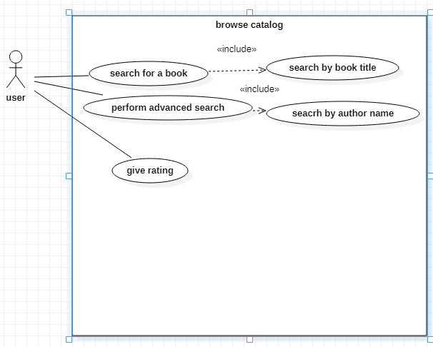

**Brief level use cases:**

**Search for a Book :**

A user can search for a book of his choice by selecting category and title. Then a select query is used to retrieve data from the database and display the selected information. The user will select a category and enter title in a text box provided. The system will display the books which matches the selected search criteria. A dataset is created as a result of select query. Later the dataset is binded to the data repeater to display the selected data.

**Perform Advanced Search:**

If the user wants to perform an advanced search he can search for a book of his choice by selecting category, title, author and price range. Then a select query is used to retrieve data from the database and display the selected information. The user will select a category and enter title, author, and price range in a text box provided. The system will display the books which matches the selected search criteria. A dataset is created as a result of select query. Later the dataset is binded to the data repeater to display the selected data.

**Give rating to a book :**

If the user wants to give rating according to his opinion for a book he can select either Excellent, Very good, good, regular or deficient. The final rating of a book will depend on all the individual user rating. The user will select a rating based on his opinion. The system will display the rating of a book and the total number of votes received.

Below is the display for various rating.

***** Excellent

**** Very Good

*** Good

** Regular

* Deficient

**Fully dressed use cases:**

|  |  |
| --- | --- |
| **Fully dressed use cases** | **Comments** |
| Name | Browse catalog |
| Scope | Online book |
| Level | Main use case |
| Primary actor | buyer |
| Stakeholder and interests | Buyer: Will search for book |
| Preconditions | Customer visit the website |
| Main success scenario | Buyer search a book and system validate that the given information of book is correct or not |
| Extensions | If the provided details are correct, the search is successful otherwise no content showed |
| Special requirements | Security , reliability , data integrity , availability |
| Technology and data variations list | Step number: possible change in technology or data format |
| Frequency of occurrence | continues |
| Miscellaneous | Who can search the app?  What will be the stock availability ? |

**Domain model:**

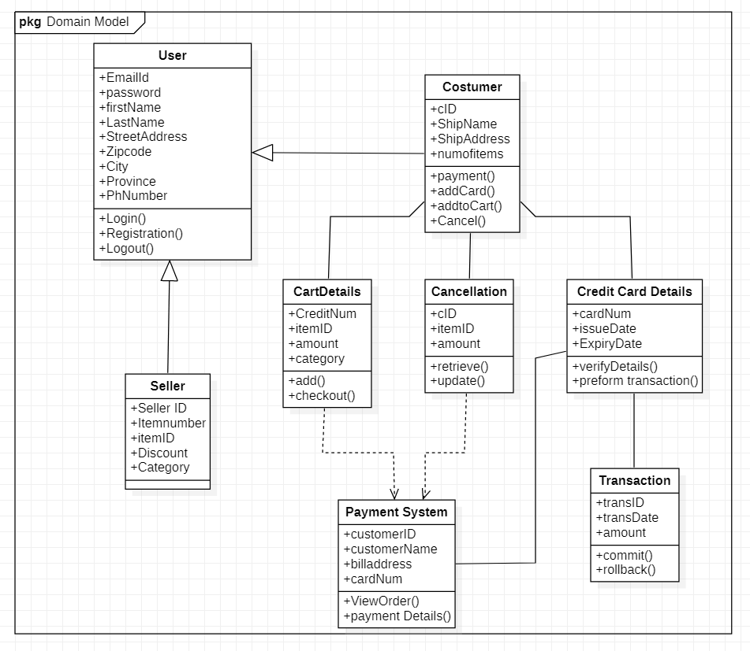

**System sequence diagrams:**

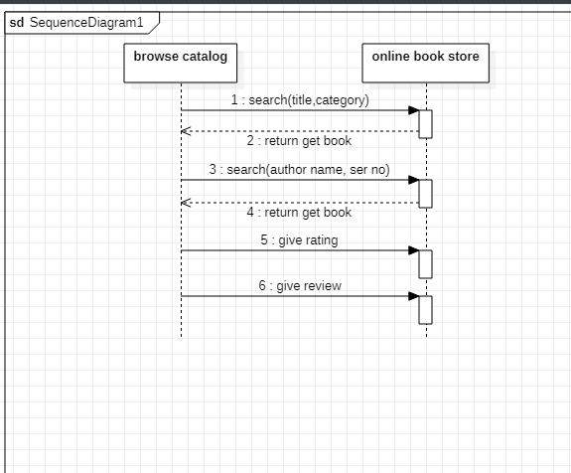

**Operation contracts:**

|  |  |
| --- | --- |
| **Operation** | search (title, category, serial no). |
| **Cross references** | use case: online book searching. |
| **Preconditions** | customer visit the website. |
| **Postconditions** | customer was entered the name or title of  book.  Result had been displayed.  Customer found the required book. |